Top tips for preparing for the post-operative diet
After your surgery, aim for at least 60g of protein per day for:
- Good energy levels
- Help with healing
- Help to maintain a healthier body composition to reduce the risk of weight regain

Please ensure you are prepared for the post-operative diet prior to your admission by purchasing at least one of the following protein options before you come into hospital in preparation for your discharge home

High protein shakes – per 100ml these should contain no more than 65 calories and 5g of carbohydrate. They should contain at least 6g of protein per 100ml. Suitable options include:
- Ufit
- Grenade Carb Killa Protein Shake
- For Goodness Shakes Ultimate Protein (split this into 2 x 240ml servings over the day)
- PhD Nutrition Diet Whey Ready to Drink
- MaxiNutrition Protein Milk
- Sci-MX Pro-2 Go Ready to Drink (split this into 2 x 250ml servings over the day)
- Myprotein Pro Milk 50 RTD 500ml (split this into 2 x 250ml servings over the day)

Slimming shakes such as Slimfast and Tesco Ultraslim, smoothies, fruit juice and probiotic drinks such as Actimel and Yakult are not suitable on the post-op diet. They do not contain enough protein and are too high in carbohydrate which may cause dumping.

Skimmed milk powder, e.g. Marvel or supermarket own brand. This can be added to hot drinks and soup.
- To make up fortified milk, add 4 tablespoons of skimmed milk powder to 1 pint of skimmed or semi-skimmed milk and use this fortified milk in drinks or to thin down soup during the day

Protein powder
- Neutral flavoured powder can be added to soups, drinks or diet yoghurt thinned with milk
- Flavoured varieties can be added to milk to make a milkshake

Soup can be homemade, or shop bought.
- Soup often contains very little protein (even chicken, oxtail and lentil varieties), so you will need to add skimmed milk powder, protein powder or fortified milk to increase the protein content.

- You may need to blend, sieve and thin soup down with extra stock, water or milk to achieve the correct liquid consistency. Initially it should be no thicker than a protein shake.

Yoghurt
- Aim for high protein varieties such as Skyr, Arla Protein, Liberte Natural 0%, Danio 0% Fat Natural or an alternative 0% fat/low fat Greek or natural yoghurt
- You will need to blend or mix with milk or fortified milk to a make drinkable consistency
- Try to choose yoghurts that contain 5g of sugar or less per 100g to avoid dumping

Equipment
We suggest purchasing the items below to help with portion control:
- Digital kitchen scales
- Small ramekin
- 5inch tea plate (please measure as most side plates are 6-7 inches)
- Blender or liquidiser for the pureed diet stage
- Measuring spoons (teaspoon, tablespoon, and dessert spoon)

You may find the following measurements helpful:
- 1 tablespoon = 3 teaspoons
- 1 dessert spoon = 2 teaspoons
- 1 level tablespoon = 15ml
- 1 level dessert spoon = 10ml
- 1 level teaspoon = 5ml

Protein powders

Product |  | Serving size | Calories (kcal) | Protein  (g) | Fat (g) | Carbs (g) | Sugars (g) | Extra info
Sanatogen High Protein Powder | 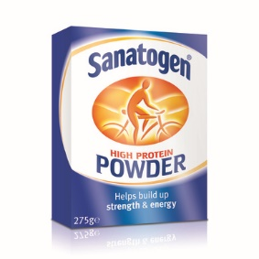 | 2 heaped teaspoons | 25 | 5.5 | 0.08 | 0.4 | 0.4 | Unflavoured.  Available in Boots or online e.g. Amazon, ChemistDirect, etc.
MyProtein Impact Whey Protein | 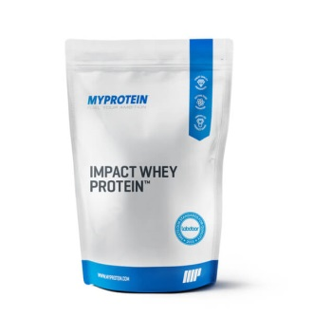 | 1 scoop -25g | 103 | 21 | 1.9 | 1 | 1 | Unflavoured *Available in over 40 flavours however nutritional values may vary by up to 15%  May contain egg
MyProtein Impact Whey Isolate | 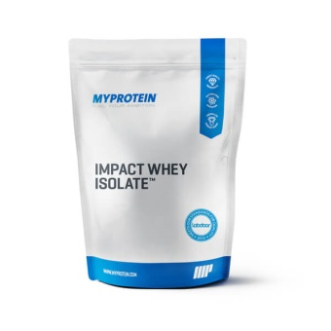 | 1 scoop – 25g | 93 | 23 | 0.1 | 0.6 | 0.6 | Unflavoured *Available in 49 flavours however nutritional values may vary by up to 15%  Made in a facility that handles egg & gluten
Protein Dynamix Whey Protein Isolate | 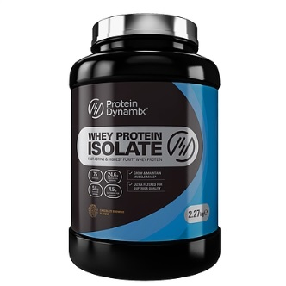 | 1 heaped scoop – 25g | 93 | 23 | 0.2 | 0.2 | 0.2 | Flavours: unflavoured, chocolate, chocolate brownie, mint choc chip, strawberry, vanilla ice-cream, banana smoothie, caramel mocha, cinnamon bun, marshmallow, jammy dodger, NY cheesecake  Suitable for vegetarians
 | 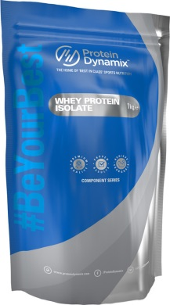
The Protein Works Diet Whey Protein Isolate 90 | 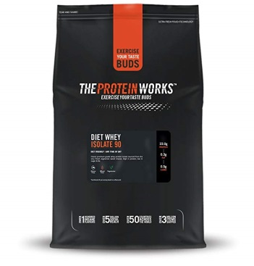 | 1 scoop - 25g | 88 - 95 | 21.9 - 23 | 0.2 - 0.4 | 0.5 – 1.4 | 0.2 – 1.2 | Available in 12 flavours however nutritional values may alter slightly  Suitable for vegetarians  Contains soya
The Protein Works Diet Whey Protein Isolate 97 | 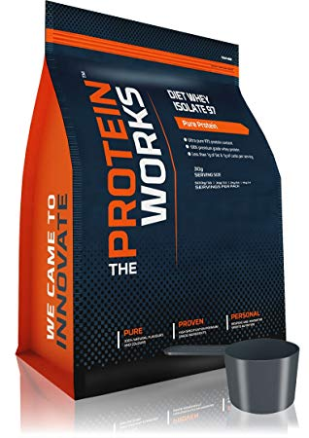 | 1 large heaped scoop - 30g | 116 – 117 | 27.7 – 27.9 | 0.4 | 0.8 – 1.0 | 0.5 - 0.8 | Flavours: strawberry & white choc, banana smooth  Suitable for vegetarians
The Protein Works Soy Protein Isolate 90 | 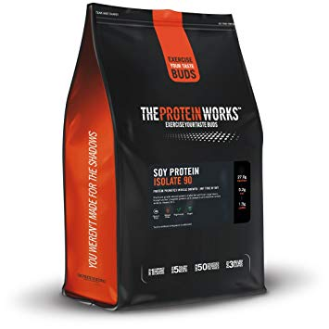 | 1 large scoop - 30g | 108 - 116 | 25.4 - 27 | 0.2 – 0.5 | 0.3 - 1.5 | 0 – 0.2 | Available in 7 flavours however nutritional values may alter slightly  Suitable for vegetarians and vegans
The Protein Works Pea Protein 80 | 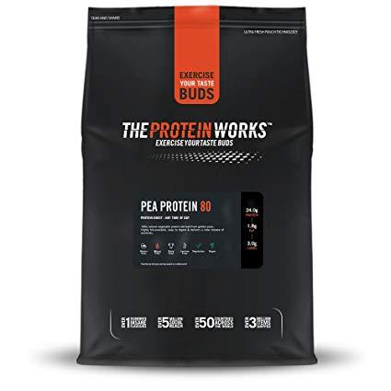 | 1 large scoop - 30g | 128 | 24 | 1.8 | 3.0 | 1.5 | Unflavoured  Suitable for vegetarians and vegans
Precision Engineered Whey Protein | 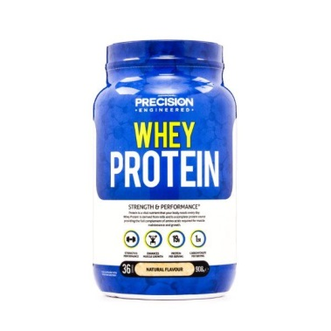 | 1 scoop – 23-27g | 84 – 106 | 17.5 – 21 | 0.7 - 1.8 | 1.2 – 2.9 | 0.014 – 2.4 | Available in 7 flavours however nutritional values may alter slightly
Holland & Barrett Soya Protein Isolate Powder Natural | 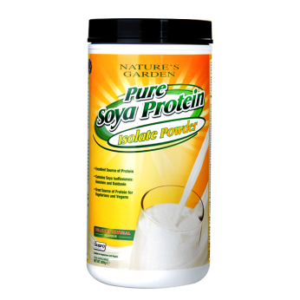 | 1 scoop – 28-31g | 110 – 116 | 24 | 1.4 | 0.3 – 1.8 | 0 – 0.1 | Available in 3 flavours however nutritional values may alter slightly  Suitable for vegetarians and vegans
Muscle Food Whey Protein Isolate 90 | 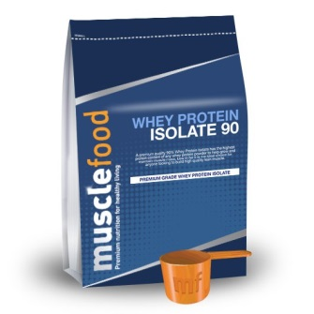 | 1 scoop - 25g | 93 | 22 | 0.5 | 0.6 | 0.2 | Available in 6 flavours however nutritional values may alter slightly  Contains soya lecithin
Muscle Food Soya Protein Isolate 90 | 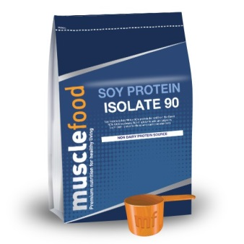 | 1 scoop - 25g | 96 | 22 | 0.8 | 0.3 | 0 | Unflavoured  Suitable for vegetarians & vegans

Whey protein isolates often contain very little or no lactose so are generally better tolerated if milk-based products cause symptoms.

Protein shakes (liquid)
Product |  |  | Serving size | Calories (kcal) | Protein (g) | Fat (g) | Carbs (g) | Sugars (g) | Extra info | Flavours
Ufit | 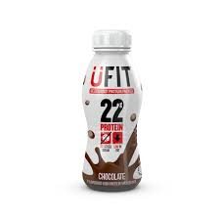 |  | 310ml | 166 | 22.4g | 3.2g | 10.7g | 10.4g | Good for diabetes control | Chocolate, strawberry, banana, iced latte
Grenade Carb Killa High Protein Shake | 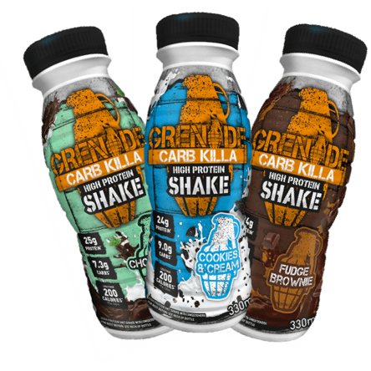 |  | 330ml | 191 - 214 | 24.0 - 25.0g | 6.6 - 8.9g | 7.3 – 9.2g | 5.0 – 8.3g | Suitable for vegetarians  Lactose free  Nutritional content varies slightly with different flavours | Banana armour, chocolate mint, cookies & cream, fudge brownie, peanut nutter, white chocolate
UFit Lactose Free | 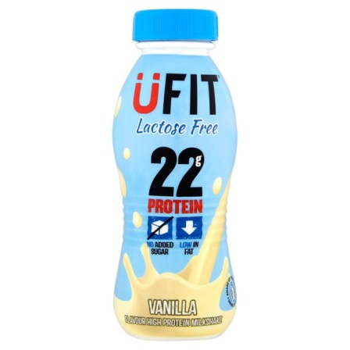 |  | 310ml | 162 | 22.0g | 3.2g | 10.0g | 10.0g | Good for diabetes control | Vanilla
For Goodness Shakes Ultimate Protein | 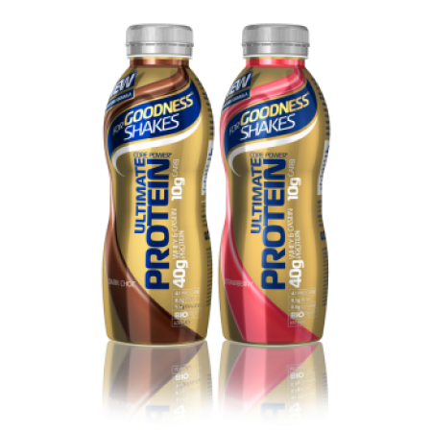 |  | 240ml  (1 bottle contains 475ml, must be spilt into 2 servings) | 117 | 20.2g | 1.2g | 5.0g | 3.8g |  | Dark chocolate, strawberry
For Goodness Shakes Plant Protein | 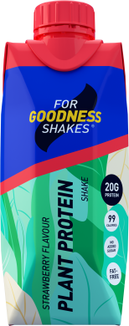 | 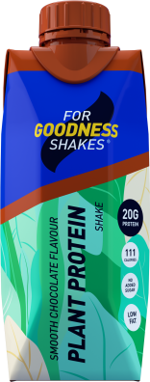 | 330ml | 110.6 | 20.0g | 1.3g | 3.6g | 0.7g | Suitable for vegans  Soya based | Smooth chocolate, strawberry, vanilla chai
PhD Nutrition Diet Whey Ready to Drink | 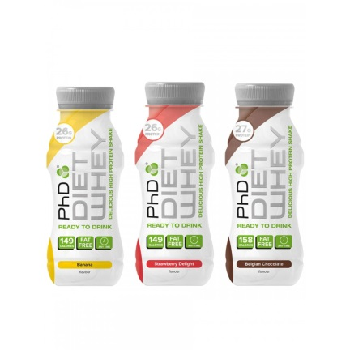 |  | 330ml | 158.4 | 26.7g | 1.3g | 9.6g | 8.9g | Suitable for vegetarians | Belgian chocolate, strawberry delight, banana
MaxiNutrition Protein Milk | 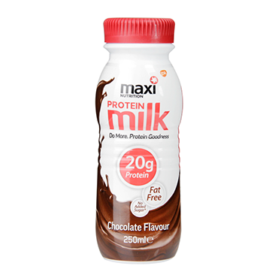 |  | 250ml | 130 | 20g | 0.4g | 12.0g | 12.0g | Suitable for vegetarians | Chocolate, strawberry
Sci-MX Pro-2 Go Ready to Drink | 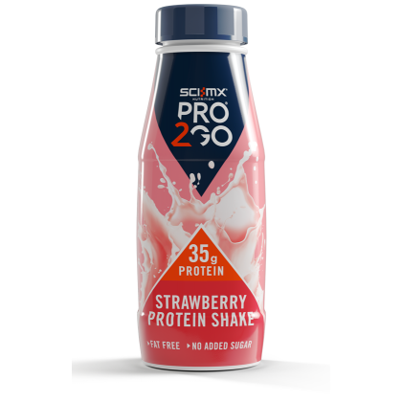 |  | 250ml  (1 bottle contains 500ml, must be spilt into 2 servings) | 115 | 17.5 | 0.5g | 9.8g | 9.0g | Suitable for vegetarians | Chocolate, strawberry
Myprotein Pro Milk 50 RTD | 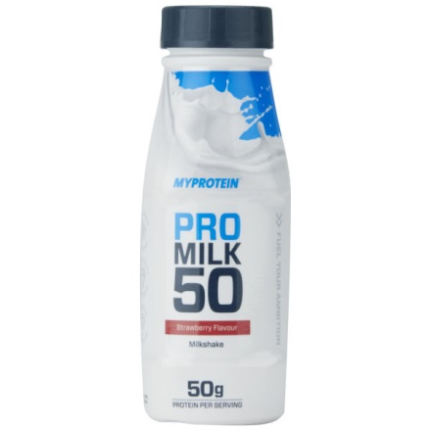 |  | 250ml  (1 bottle contains 500ml, must be spilt into 2 servings) | 170 | 25.3g | 1.0g | 13.5g | 12.3g | Not suitable for vegetarians  Not halaal | Strawberry, banana, chocolate, vanilla
V24 Protein shot | 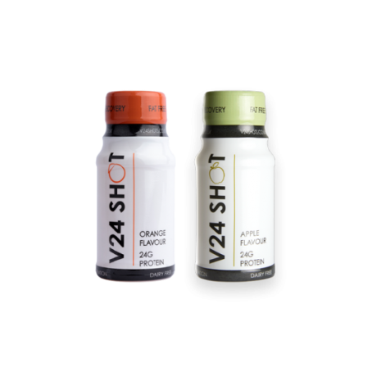 |  | 60ml | 97 | 24g | 0.0g | 0.13g | 0.0g | Dairy free  Not suitable for vegetarians – based on hydrolysed collagen | Apple, orange

